Fitzroy to Gladstone Pipeline
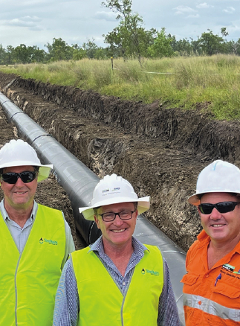
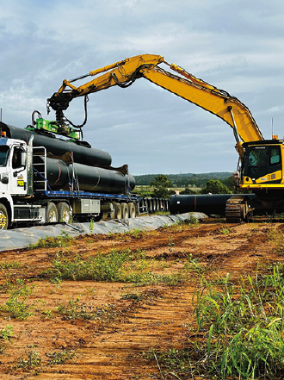

Project: Fitzroy to Gladstone Pipeline
Customer: McConnell Dowell
End User: Gladstone Area Water Board
Location: Gladstone, Queensland
Completion: 2024
Supplied: 106km X 1067 Pipeline

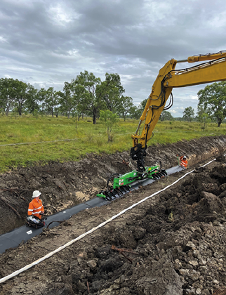
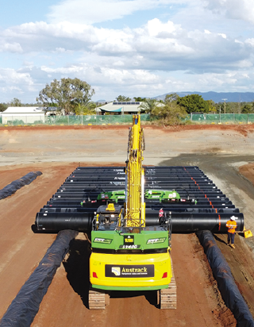


Project Need:
The Fitzroy to Gladstone Pipeline (FGP) is a major $983 million infrastructure project designed to secure the long-term water needs of the Gladstone region in Central Queensland. Its primary objective is to mitigate the single-source water supply risk posed by reliance on Awoonga Dam, ensuring the region has a resilient and diversified water supply to support both community needs and future industrial growth.
Stretching approximately 117 kilometres, the pipeline integrates a network of critical infrastructure, including a new water treatment plant, multiple reservoirs, and several pumping stations strategically positioned at key locations Laurel Bank, Alton Downs and Aldoga. Once operational, the pipeline will have the capacity to transport up to 30 gigalitres of water per year from the Fitzroy River near Rockhampton to Gladstone. This increased capacity not only secures the region’s residential and industrial water needs but also plays a vital role in supporting emerging industries, particularly the growing hydrogen sector in Gladstone via growth in Queenslands renewable energies sector. By providing a more reliable and sustainable water supply, the FGP underpins Queensland’s broader vision for industrial diversification and clean-energy development. Overall, the Fitzroy to Gladstone Pipeline stands as a transformational investment, contributing to water security, economic resilience and quality water infrastructure.

Solution:
Steel Mains supplied 106 km of Sintakote® steel pipeline for the Fitzroy to Gladstone Pipeline project, extending from the Lower Fitzroy River in Rockhampton and integrating seamlessly with the Gladstone Area Water Board’s existing network at Yarwun. This extensive delivery formed a critical component of the region’s long-term water security strategy, ensuring reliable transfer capacity across variable ground conditions.
Backed by more than a century of Australian manufacturing excellence, Steel Mains brought unmatched technical capability to the project. The use of Sintakote® was instrumental in ensuring pipeline longevity and structural resilience, leveraging Steel Mains’ world-leading coating and lining technologies. With a fusion-bonded polyethylene coating applied under controlled factory conditions, Sintakote® delivers exceptional coating integrity, engineered to outperform in both above-ground and buried applications. Its proven resistance to mechanical impact, moisture ingress, and environmental degradation provides superior durability, even in corrosive soils, abrasive terrains, and other high-stress environments commonly encountered across regional Australia.
By utilising Steel Mains’ pipelines and streamlined manufacturing approach, the Fitzroy to Gladstone Pipeline project achieved significant efficiencies, including reduced installation timelines, lower construction risk, and long-term operational cost savings. The result was a reliable, economical corrosion protection solution capable of supporting the region’s evolving water needs for decades to come. Ultimately, Steel Mains delivered a solution that not only met the immediate performance demands of the infrastructure but also provided reliable, economic, long-term protection for the Fitzroy Gladstone area.

Achievement:
The 117km Sintakote pipeline from Fitzroy to Gladstone successfully achieved long-term water security and continued operations of Gladstone’s water industry. This large-scale infrastructure project not only delivered essential water security but also generated significant economic and social benefits throughout its construction phase. At its peak, the project supported more than 400 jobs across a diverse range of disciplines, helping stimulate local employment and regional capability. Through strong engagement with local contractors and suppliers, this project created 25 apprenticeships and traineeships, contributing to workforce development with over 10,000 hours of structured training provided to the delivery team. In addition to building local skills, the pipeline demonstrated a strong commitment to diversity and inclusion by actively partnering with Indigenous businesses and facilitating meaningful Indigenous participation across multiple stages of construction. This approach highlights the project’s broader contribution to social sustainability, supporting long-term community development and greater representation within the water industry.
Steel Mains’ successful delivery of high-quality Sintakote steel pipe was central to the project’s achievements. Steel Mains durable, corrosion-protected pipeline solution ensured efficient, reliable installation within project timelines, reinforcing Steel Mains’ reputation for manufacturing trusted water infrastructure. The project stands as a testament to Steel Mains’ quality, innovation, and long-standing commitment to providing complete steel pipeline systems that support the water needs of Australian communities.

